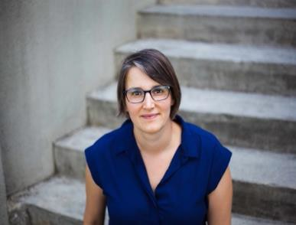
PARENTING
THROUGH
SEPARATION
AND DIVORCE

FREE SERVICE PROVIDER WORKSHOP
MARCH 2ND
12:00 – 1:00PM LUNCH & LEARN

This 1-hour session will help you gain a deeper understanding of the impact of separation and divorce on young children and their caregivers. We will explore how service providers can better support families navigating these kinds of transitions.

Amanda Thiessen has worked with families throughout her 20-year career as a social worker. She is currently a Parent Support Counsellor at Cameray Child and Family Services supporting families in New Westminster and Burnaby with children under 6.

Register on Eventbrite:
https://www.eventbrite.com/e/276118075597

