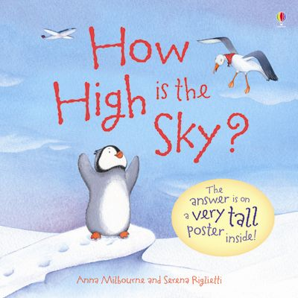

Book: How High is the Sky?
Author: Anna Milbourne and Serena Riglietti

Follow the adventure of Pipkin the curious penguin as he goes on an adventure of self-discovery into the sky. With the help of a wandering albatross, a monkey in a hot-air balloon, and a rabbit in a rocket, Pipkin goes all the way to the moon to discover just how high is the sky really is. “How High is the Sky?” takes readers along for the ride with Pipkin up past the birds, up past the clouds, up past the blueness, and all the way up to the moon. This book comes with a long poster included that illustrates the wonders of above, along with some interesting facts about the sky and outer space. This is an excellent book to encourage your child to ask questions, to be curious, and even to go out and seek answers!

Join Pipkin on some of his other quests of discovery with books such as “How Deep is the Sea?” and “How Big Was a Dinosaur?”

Discover the sky along with your child

The sky is a fantastic and free, science learning source. There are countless opportunities for you and your child to use the sky as a way to discover and peak their interest about the natural world around them. Get outside for some fresh-air with your child and look up into the sky where there is so much to see. Here are a few of our suggestions of simple activities involving the sky:

- Point out things in the sky and help your child learn the names.
- Observe what you can see in the sky during the day.
- Observe what you can see in the sky at nighttime.
- Examine the colours of the sky, and how they change from day to night.
- Lay-down on the ground with your child and point-out shapes and animals in the clouds.
- Go stargazing

